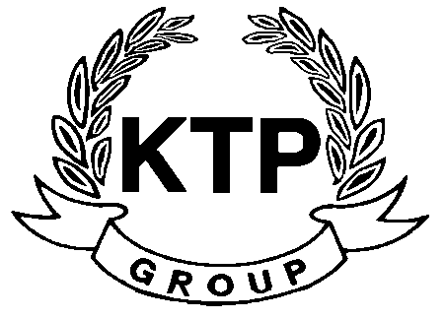
KTP HOLDINGS LIMITED
港台集團有限公司*
(Incorporated in Bermuda with limited liability)
(Stock code: 645)

Suspension of Trading

As the request of KTP Holdings Limited (the “Company”), trading in the shares of the Company will be suspended with effect from 9:30 a.m. today (15 April 2008) pending the release of an announcement in relation to information which is price sensitive.

As at the date of this announcement, the Board is comprised of 5 Directors, of which Mr. LEE Chi Keung, Russell and Miss. YU Mee See, Maria are executive Directors, Mr. NG Wai Hung, LEE Siu Leung and Mr. YUEN Sik Ming are independent non-executive Directors.

By Order of the Board
KTP Holdings Limited
Lee Chi Keung, Russell
Chairman

Hong Kong, 15 April 2008

*For identification purpose only

